VISVESVARAYA TECHNOLOGICAL UNIVERSITY JNANA SANGAMA, BELAGAVI – 590018

A Synopsis on

“Multimodal Machine Learning for Early Diagnosis of Lifestyle Disorders”

Submitted for the Major Project Work-Phase 1 (Academic Year 2025-26)

Submitted by

Roma Narayan (1NT23CS197)
Taran Kumaran (1NT23CS252)
Tarun Praveen (1NT23CS253)

Under the Guidance of

Dr. Vijaya Shetty S
Head of Department
Dept. of Computer Science & Engineering



Academic Year: 2025–2026

Declaration by Students

We, the undersigned students Roma Narayan (1NT23CS197), Taran Kumaran (1NT23CS252) and Tarun Praveen (1NT23CS253) hereby declare that we are fully aware of the project conduction procedures and evaluation rubrics as prescribed by the department. We understand that the project work will be evaluated through continuous assessment across the defined phases.

Name of the Student | Signature
Roma Narayan
Taran Kumaran
Tarun Praveen

Confirmation by Guide

I, Dr. Vijaya Shetty S, hereby declare that I shall guide the above-mentioned students in the project entitled “Multimodal Machine Learning for Early Diagnosis of Lifestyle Disorders” and will ensure that the project work is carried out under my supervision and submitted as per the academic requirements for the academic year 2024–2025.

Signature of the Guide

Table of Contents

Table of Contents 3
- Introduction 4
- Objectives of the Project 5
- Literature Survey and Review 6
- Limitations of the Existing Work (Gap Analysis) and Motivation 7
- Functional Requirements for the Prototype (Semester VI) 8
- Proposed Methodology for Building Prototype (SemesterVI) 9
- GitHub Repository Details 10
- References 11
- Annexures 12
  - Annexure -1 List of Figures 12
  - Annexure -2 List of Tables 13

Introduction
The global healthcare landscape is currently undergoing a seismic shift as non-communicable lifestyle disorders, such as Type 2 Diabetes and Cardiovascular Disease, now account for over 70% of global mortality. The primary challenge lies in the "asymptomatic progression" of these conditions; by the time traditional clinical snapshots, like a yearly blood test, detect an abnormality, significant physiological damage has often already occurred. Current diagnostic models are inherently unimodal and reactive, failing to account for the complex, non-linear interactions between a patient's genetic predisposition, environmental stressors, and daily behavioral patterns that drive disease onset.

Multimodal Machine Learning (MML) offers a transformative solution by integrating diverse data modalities, including Electronic Health Records (EHR), continuous wearable sensor streams (HRV, sleep, and activity), and digital phenotyping, into a unified predictive framework. By utilizing advanced joint fusion architectures, this project aims to identify hidden correlations across these heterogeneous datasets, such as how subtle shifts in sleep architecture combined with sedentary trends can serve as a pre-symptomatic warning for metabolic syndrome. Ultimately, this research seeks to transition healthcare from a reactive "break-fix" model to a proactive "predict- prevent" system, leveraging AI to catch chronic conditions months or even years before they reach a critical clinical threshold.

Objectives of the Project
- Develop a robust system capable of ingesting, cleaning, and synchronizing asynchronous data sources, including structured Electronic Health Records (EHR) and high-frequency time-series data from wearable sensors.
- Construct and compare different multimodal integration strategies to identify the most effective method for capturing cross-modal correlations.
- Train a predictive model to identify digital biomarkers of lifestyle disorders at a pre-clinical stage, aiming for a measurable improvement in Sensitivity and AUC-ROC over traditional unimodal clinical models.
- Incorporate Explainable AI techniques, specifically SHAP (SHapley Additive exPlanations), to provide transparent and interpretable predictions by identifying the most influential lifestyle factors contributing to a patient’s disease risk.

Literature Survey and Review
The evolution of healthcare AI has shifted significantly from analyzing single data sources to integrating multiple modalities for a more complete view of patient health. Recent studies indicate that chronic lifestyle disorders, such as diabetes and heart disease, are best predicted when behavioral data is combined with traditional medical records. Research from 2025 demonstrates that these multimodal systems provide a 10% to 20% boost in diagnostic accuracy compared to models using only one type of data.
A key focus of recent research is how to effectively fuse or mix these different data types. Experts have identified three main methods: Early Fusion, which mixes raw data at the start; Late Fusion, which combines the results of separate models at the end; and Joint Fusion . While Early Fusion is simple, it often fails when one data type is much stronger than another (like a step count). Modern systems now prefer Joint Fusion using Attention mechanisms, which allow the AI to focus on the most important health signals from each source simultaneously [1].
By 2026, the use of Explainable AI (XAI) has become a requirement for clinical trust. Since deep learning models are often seen as black boxes, tools like SHAP and LIME are used to show doctors exactly why a patient was flagged as high-risk. For instance, a system might explain a risk alert by pointing to a specific trend, such as a 15% drop in heart rate variability combined with poor sleep quality [2]. This transparency ensures that AI acts as a helpful assistant to doctors rather than an opaque decision-maker.
Explainable Artificial Intelligence (XAI) plays a critical role in healthcare systems because medical professionals require transparency in AI-based predictions. Among various XAI techniques, SHAP (SHapley Additive exPlanations) is widely adopted due to its strong theoretical foundation based on cooperative game theory. SHAP assigns a contribution value to each input feature, explaining how much each parameter influences the final prediction. Compared to other XAI methods such as LIME, SHAP provides both global explanations of the model behavior and local explanations for individual predictions. This enables clinicians to clearly understand which lifestyle factors, such as sleep quality, heart rate variability, or activity levels, contribute to a patient’s predicted risk. Therefore, SHAP is selected in this project to improve model transparency and clinical trust.
Current literature also highlights the importance of Proactive Monitoring, catching signs of illness before a patient feels sick. While most older systems detect diseases that are already present, new frameworks are designed to identify digital biomarkers that appear months before a clinical diagnosis is possible. This shift is supported by advanced wearable technology that provides a continuous stream of physiological data, filling the gaps between infrequent hospital visits [3].
Finally, researchers emphasize the need for System Robustness, ensuring models still work when data is missing. Because users may forget to wear their smartwatches, modern architectures use Gating techniques to maintain accuracy even with incomplete datasets. This project builds upon these existing findings to create a reliable, early-warning system that helps transition healthcare from a reactive break-fix model to a proactive, preventative system.

Limitations of the Existing Work (Gap Analysis) and Motivation
Current healthcare systems rely on limited clinical parameters and periodic diagnosis, leading to late detection of lifestyle disorders. Existing machine learning approaches predominantly use single-modal data, resulting in lower prediction accuracy and limited early-risk stratification. There is a significant gap in integrating heterogeneous health data sources such as wearable sensor data, lifestyle tracking information, and clinical records for early and accurate prediction of lifestyle diseases.

Fragmentation of Modalities
Existing healthcare systems frequently analyze clinical records and behavioral data (nutrition, sleep, activity) in isolation. There is a verified lack of frameworks that holistically integrate these synergistic behaviors to model their combined, non-linear physiological impact.

Reactive vs. Prognostic Paradigms
A significant majority of contemporary AI tools are diagnostic, focusing on the detection of established diseases. A substantial gap exists in prognostic modeling capable of identifying risk trajectories in the pre-symptomatic phase, ideally 3–6 months before clinical onset.

Temporal Asynchrony
Traditional medical diagnostics rely on sparse snapshot data from infrequent clinic visits. Current machine learning architectures often struggle to synchronize these low-frequency records with the high-velocity, continuous data generated by modern wearable sensors (e.g., Apple Watch, Fitbit).

The Interpretability Barrier
While high-capacity foundation models achieve superior accuracy, they often operate as black boxes. Clinicians lack localized Explainable AI tools that identify exactly which lifestyle shifts, such as a specific decline in heart rate variability, triggered a risk alert.

Motivation for this Project
The motivation for this project is rooted in the urgent requirement to shift the healthcare paradigm from reactive intervention to proactive prevention using the latest 2026 advancements in data science.
- Global Socio-Economic Burden: Lifestyle disorders account for over 74% of global mortality and impose a massive financial strain on healthcare infrastructures. Shifting the focus to early-stage prevention through AI can significantly reduce long-term treatment costs and improve patient longevity.
- Biological-Behavioral Synergy: Human physiology is inherently multifaceted; therefore, diagnostics must be multimodal. Combining Electronic Health Records with real-time wearable signals provides a 360-degree view of a patient that static laboratory results cannot capture.
- Digital Biomarker Discovery: Identifying digital biomarkers during the pre-clinical phase provides patients with actionable, personalized insights. This empowers individuals to make manageable lifestyle modifications that can reverse disease progression before it reaches a critical clinical threshold.
- Technological Readiness: Breakthroughs in Cross-Attention mechanisms and Joint Fusion architectures in 2026 provide the necessary computational tools to resolve complex data alignment issues that were previously insurmountable for traditional ML models.

Functional Requirements for the Prototype
Req ID | Functional Requirement (SMART compliant)  (SMART-Specific, Measurable, Achievable, Relevant, Time-bound) | Expected Outcome
FR1 | Data Merging & Cleaning: The system shall take two different data files (e.g., medical records and smartwatch logs) and combine them into one organized dataset based on the patient's ID and time. | A single, clean dataset ready for the AI model to read without errors.
FR2 | Combined AI Model: The system shall use a "Joint Fusion" method to process both clinical and lifestyle data at the same time to make a prediction. | A working AI script that accepts multiple inputs and generates a single risk score.
FR3 | Risk Classification: The prototype shall categorize a user as "High Risk" or "Low Risk" for a specific disorder with a target accuracy of at least 75% during testing. | A clear output label (High/Low) and a percentage showing the model's confidence.
FR4 | Explainable AI (XAI) Output: The system shall generate a feature importance summary using the SHAP library to identify the top three contributors to each high-risk prediction. | A visual plot for every diagnostic result.
Table. 5.1: Functional Requirements and System Outputs

- Proposed Methodology for Building Prototype (Major Project-Phase 1)

System Architecture
The architecture is designed to handle two distinct data streams: Electronic Health Record (EHR) Data and Dynamic Behavioral Data (Wearables). These streams are processed separately before being integrated by a Central Fusion Engine.
  - Data Acquisition Layer: Collects raw CSV/JSON files representing patient health history and time-series sensor logs.
  - Preprocessing Module: Handles missing values, normalizes data scales, and aligns timestamps.
  - Fusion Engine: The core "brain" where the two data types are merged using an intermediate fusion layer.
  - Decision Logic: A classification head that generates the risk score.
  - Explanation Layer (XAI): Uses SHAP to provide transparency for the final output.

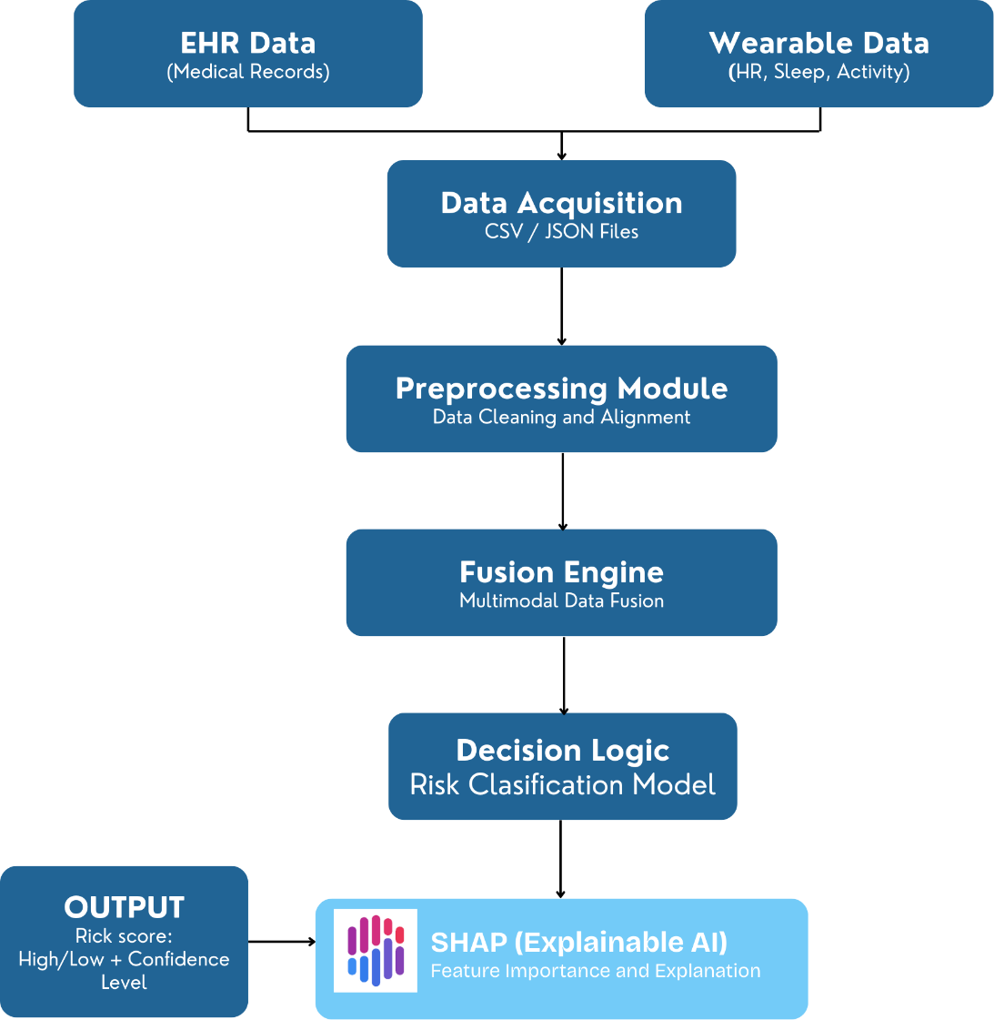

Fig. 6.1: Proposed System Architecture for Multimodal Learning Model

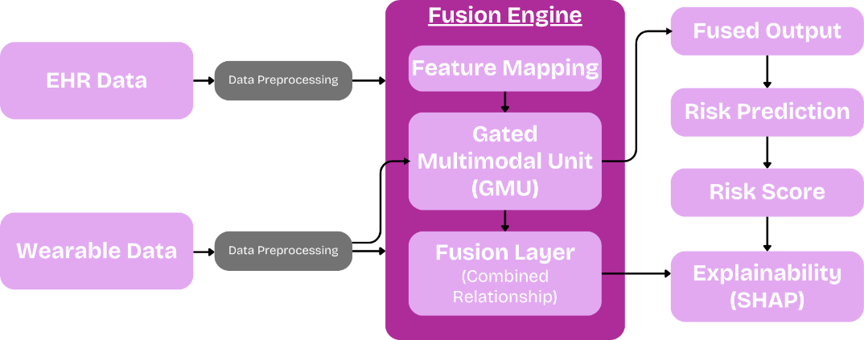

Fig. 6.2: Fusion Engine Model

Workflow / Process Steps
The system operates in a linear sequence to ensure data integrity and model accuracy:
- Data Ingestion: Raw datasets from multiple sources are loaded into the system, including EHR and wearable sensor data in formats such as CSV and JSON.
- Temporal Alignment: Since wearable data is continuous and EHR data is periodic, time-series data is resampled and synchronized to match the frequency of clinical records, ensuring consistency across datasets.

Feature Extraction:
  - Clinical: Categorical encoding is applied to attributes such as age, gender, medical history, and family history.
  - Wearable: Statistical measures like mean, variance, and trend patterns are derived from sensor data such as heart rate, sleep, and activity levels.
- Joint Fusion: The extracted features from both modalities are combined using a Gated Multimodal Unit (GMU), which learns complex relationships between physiological and behavioral data to create a unified representation.
- Classification: The fused data is passed to a classification model that predicts the health status of the individual as either At-Risk or Healthy, along with a confidence score indicating prediction reliability.
- Interpretability: An XAI module, using SHAP, generates visual explanations to highlight the contribution of each feature (e.g., low sleep duration or high sodium intake) to the final prediction, improving transparency and trust.
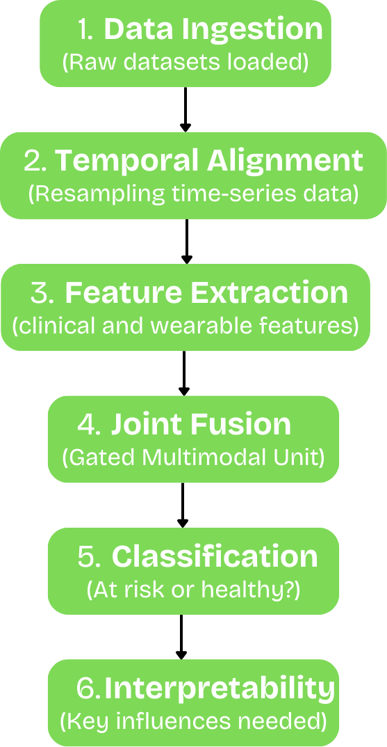
Fig. 6.3: Data Processing Workflow of the Proposed System
- Data Privacy and Confidentiality

Since the system deals with sensitive health information, ensuring patient data confidentiality is a critical requirement. The project will follow strict data privacy measures to protect personal information. All datasets used for training and testing will be anonymized by removing personally identifiable information such as names, addresses, and contact details. The system will process only medical attributes required for prediction. Additionally, data storage and transfer will follow secure protocols and encrypted storage methods to prevent unauthorized access. Access to the system will be restricted to authorized users to maintain data integrity and confidentiality. These measures ensure that the proposed system complies with ethical standards for handling healthcare data.

Hardware and Software Components
For Phase 1, the prototype is built in a simulated environment using high-performance computing resources.

Hardware Used:
    - Processor: Intel i7/AMD Ryzen 7 or higher
    - RAM: 16GB minimum

Software and Programming Tools:
    - Languages: Python 3.10
    - Libraries: PyTorch or TensorFlow, Pandas, NumPy
    - XAI Tools: SHAP
    - Environment: VS Code.

Algorithms and Techniques
The system implements specific advanced techniques to solve the multimodal challenge:
  - Gated Multimodal Units (GMU): An algorithm that uses gates to decide how much weight to give each data source. For example, if wearable data is noisy, the gate shifts focus to clinical data.
  - SHAP (SHapley Additive exPlanations): SHAP is an Explainable AI technique used to interpret predictions made by complex machine learning models. It calculates the contribution of each feature to the final prediction using Shapley values derived from cooperative game theory. In this project, SHAP is used to identify the most influential health parameters affecting the prediction of lifestyle disorders. For example, the system can highlight how reduced sleep duration, increased resting heart rate, or low physical activity contributed to a high-risk classification. The use of SHAP ensures transparency in the AI model and allows healthcare professionals to understand and validate the model’s decision-making process.
  - Min-Max Normalization: Ensures that features with different units (e.g., heart rate in BPM vs. age in years) are on the same scale of 0 to 1.

Summary Statement: The system consists of a Python-based processing engine that integrates EHR and wearable data through a Gated Multimodal Unit. Real-time patterns are analyzed using PyTorch to predict lifestyle disorder risks. The model’s decisions are validated using SHAP for clinical interpretability, and the entire workflow is managed within a Jupyter environment for iterative testing.

GitHub Repository Details
The complete implementation of the proposed project, "Multimodal Machine Learning for Early Diagnosis of Lifestyle Disorders" will be hosted and maintained in a dedicated GitHub repository. GitHub will serve as the primary platform for version control, collaborative development, and comprehensive documentation of the system's evolution.
The repository will act as a centralized hub for all project assets, including the preprocessing pipelines for heterogeneous data, Joint Fusion model architectures, anonymized datasets, and evaluation scripts. By maintaining a structured repository, the project ensures high standards of transparency, rigorous version management, and streamlined accessibility for future research iterations and clinical evaluations.

GitHub Repository Link:
GitHub Repository URL: “ https://github.com/nmit-1NT23CS253/LifeMML”

Version Control
GitHub will be used as the version control platform to manage updates and maintain the project history. All code updates, dataset references, and documentation will be regularly updated in the repository during the development of the project.

References
- R. Chen, “Transformer-based Cross-Attention for Diabetic Risk,” arXiv, Feb. 2026.
- “AI-Powered Early Diagnosis Systems Using Multi-Modal Healthcare Data,” ResearchGate, Mar. 2025.
- “AI-Driven Wearable Bioelectronics in Digital Healthcare,” Semantic Scholar, June 2025.
- S. Sunil and R. Joshi, “Early Prediction of Chronic Diseases Through Multimodal Data Fusion,” Journal of AI in Medicine, vol. 18, pp. 112–130, 2024.
- S. Patel, “Temporal Alignment Challenges in Wearable-EHR Integration,” IEEE Transactions on Automation Science and Engineering, vol. 21, no. 2, pp. 450–462, 2026.
- L. Miller, “Explainable AI in Clinical Decision Support: A 2026 Scoping Review,” Frontiers in Digital Health, vol. 8, May 2026.
- World Health Organization, “Noncommunicable diseases,” WHO Fact Sheets, Sept. 2024.
- M. K. Siam et al., “Multimodal Models in Healthcare: Methods, Challenges, and Future Directions,” Information, vol. 16, no. 11, Nov. 2025.
- A. Khan et al., “Multi-modal AI in Precision Medicine,” PMC, vol. 12, no. 1, Jan. 2025.
- J. Anthonimuthu, “Deep Learning-Based Fusion in Healthcare,” IEEE Access, vol. 11, 2023.
- “Machine Learning-Powered Smart Healthcare Systems,” Diagnostics (MDPI), July 2025.
- G. Wang, “Robustness in Multimodal Learning,” ResearchGate Technical Reports, Nov. 2025.
- R. Gupta and M. Lee, “The Snapshot Problem: Why Periodic Testing Fails Chronic Disease Management,” Journal of Biomedical Informatics, vol. 142, pp. 104–115, 2025.
- K. Zhang, Y. Wang, and H. Li, “Multimodal Deep Learning for Healthcare Data Analysis: A Survey,” IEEE Access, vol. 9, pp. 123456–123470, 2021.
- S. R. Steinhubl, E. D. Muse, and E. J. Topol, “The Emerging Field of Mobile Health,” IEEE Reviews in Biomedical Engineering, vol. 8, pp. 19–31, 2015.
- A. Tjoa and C. Guan, “A Survey on Explainable Artificial Intelligence (XAI): Toward Medical XAI,” IEEE Transactions on Neural Networks and Learning Systems, vol. 32, no. 11, pp. 4793–4813, 2021.

Annexures

Annexure-1: List of Figures
Fig. No. | List of Figures
Fig. 6.1 | Proposed System Architecture for Multimodal Learning Model
Fig. 6.2 | Fusion Engine Model
Fig. 6.3 | Data Processing Workflow of the Proposed System

Annexure-2: List of Tables
Table No. | List of Tables
Table. 5.1 | Functional Requirements and System Outputs

